**Overview**

The purpose of this presentation is to explore the validity of Microsoft’s potential entry into the movie business. The presentation will briefly discuss the Background of the company, its strengths and make a case for why Microsoft can succeed in this business venture.

Background

Microsoft was founded in 1975 by Bill Gates and Paul Allen, globally renown as a software provider it was the largest software marker by in 2022. Though primarily known for its software Microsoft has demonstrated versatility and an understanding of other markets by successfully venturing into hardware through products as the XBOX gaming console and the line of surface tablets which are used worldwide.

Business case

The film industry is traditionally viewed as a high-risk endeavor to undertake with numerous stories of box office ‘bombs’ however with careful analysis of available data we believe that it presents a set of unique opportunities that are worth investigating. First off is the value of diversification that will increase our revenue streams. Additionally films themselves generate multiple revenue streams from movie tickets, DVD sales, streaming subscription services among others. Most of these revenue streams can continue to generate profits long after a movie has left the theatres.

**Business Understanding**

As stated earlier the film industry is viewed as high risk where success or failure can hardly be determined. As such using data analysis the main objective for this will be seeking to understand and identify the characteristics that can increase the probability of success for this new venture.

By analyzing the data and determining what factors contribute to a movies success Microsoft can make informed decisions that minimize the risks that are traditionally associated with this venture and continue Microsoft’s history of success in a diverse range of markets.

**Data Understanding**

The data used for this was obtained from two sources. One source was IMDB with genre, year and rating being the key items of interest that resulted in a combined data set of 73856 rows and 7 columns. The other source was Box-office with domestic gross and foreign gross being the key features of interest that produced a dataset of 3387 rows and 5 columns.

The first step was to combine the two datasets into one cohesive set that served as the foundation for the analysis. The objective was to provide a link between the various factors such as genre, year, rating, domestic gross and foreign gross to determine what are the characteristics of a successful movie to identify patterns that can be of use when examining the industry.

Data Analysis

In this stage the first step before proceeding further was to understand the overall state of the movie industry first in order to determine whether the venture was worthwhile. For this I determined the critical metrics to consider were total gross revenue which is a combination of domestic gross and foreign gross as well as the year the movie released. This will provide us with an overview of how the movie industry as a whole has performed year on year and provide crucial insights into the profitability of the venture.

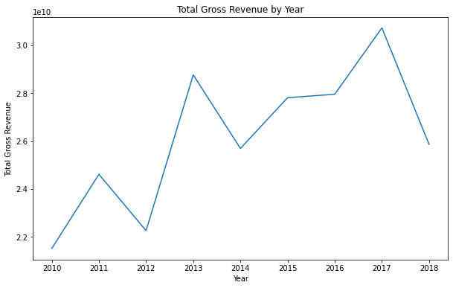

It seems the growth is not as stable as expected however despite market shocks there is a general upward trend indicating that the market has been experiencing overall growth.

The next criteria were to determine what types of movies were successful. For this the key metrics considered were the genre of the movie produced against the total revenue generated per genre

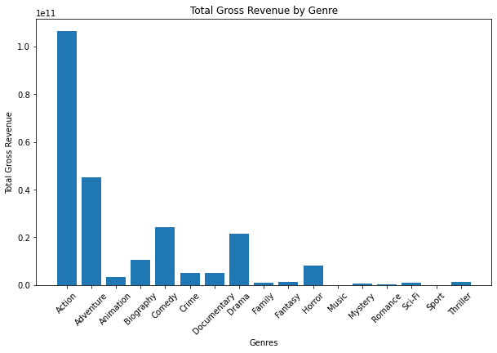

This bar chart gives us an idea of the types of movies that are most likely to succeed with action, adventure comedy and drama being the biggest earners.

The next analysis was to give us insight into the types of movies that the competitors as they can provide a strong indicator of consumer trends in the market as well as idea of profitability

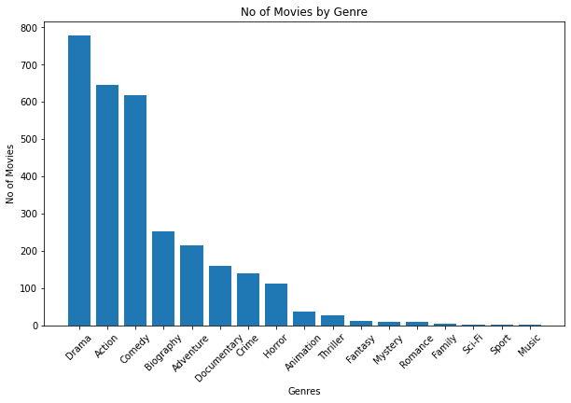

Here we can see that surprisingly Action is not the highest despite raising the largest revenue by a significant margin meaning some films are very high earners leading to the graph we saw earlier. The most made films are drama, action, ­­comedy and biography. Indicating that this are the genres while not significant earners might have a more reliable return on investment

Recommendations

As such based on this we can determine that the movie venture as a whole appears to be a profitable and presents a unique opportunity to generate revenue. Furthermore, given that action, adventure and comedy are the biggest earners those should be important genres to consider when branching out into the film industry as opposed to focusing on one. Additionally, action movies seem to have high competition despite the high revenue as such its essential to consider other genres such as adventure that while not as frequently produced high earning results making it a field that is easier to penetrate the market and provide significant revenue.

**Next Steps**

As we can see the data on movies produced ends in 2018 to be competitive in the industry, we need up to date data on the types of movies being consumed now to get better insight into consumer trends.

Another factor to consider is return on investment as some low-cost genre movies may generate more consistent profits as opposed to higher cost ones. Finally, to obtain and analyze data from streaming services to see how best we can leverage their use in the future.